TUGAS

Web Services

Northwind SQL

Nama : Afridho Tattaq T.

NIM : 2201530030

* Perintah GET

*http://localhost/php-crud-api/api.php/records/products/*

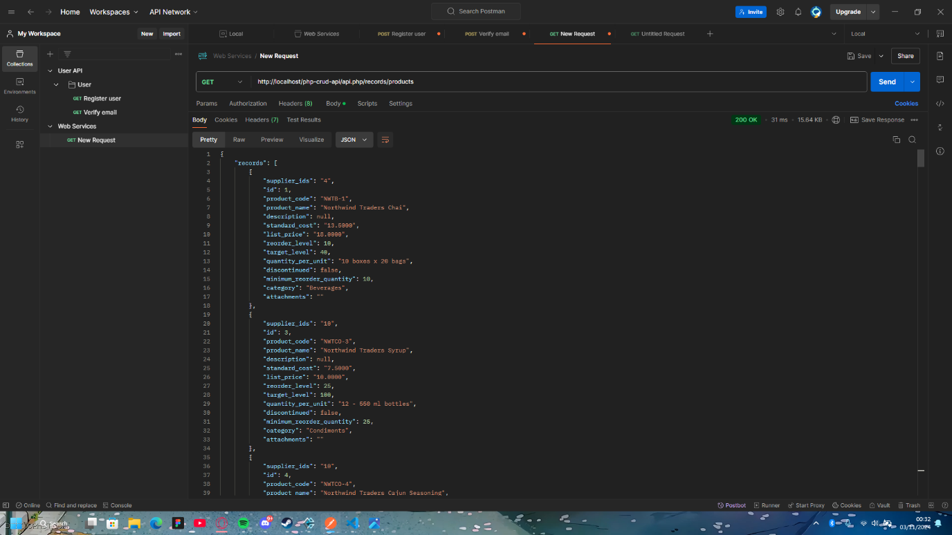

* Perintah POST

*http://localhost/php-crud-api/api.php/records/products/*

{

  "supplier_ids": "12",

  "product_code": "NWTB-1",

  "product_name": "Acumalaka",

  "description": null,

  "standard_cost": "2.500",

  "list_price": "18.0000",

  "reorder_level": 10,

  "target_level": 40,

  "quantity_per_unit": "10 boxes x 20 bags",

  "discontinued": false,

  "minimum_reorder_quantity": 10,

  "category": "Beverages",

  "attachments": ""

}

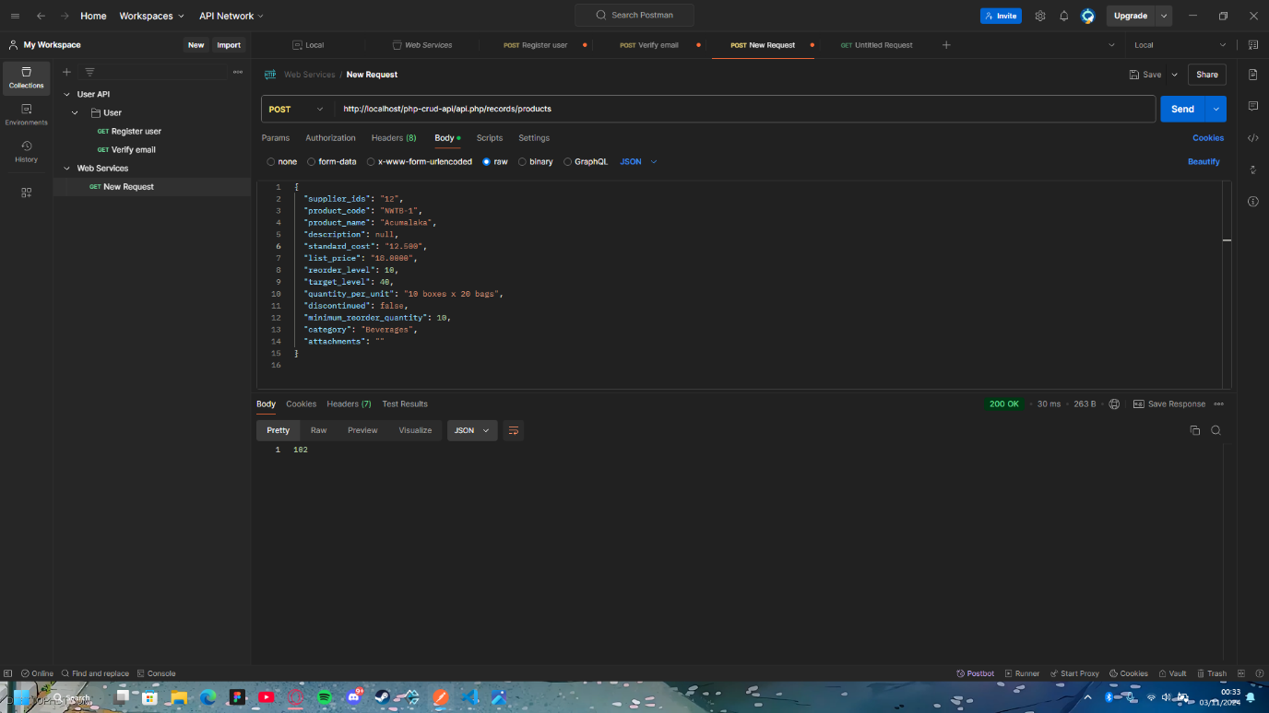

**Hasil Output :**

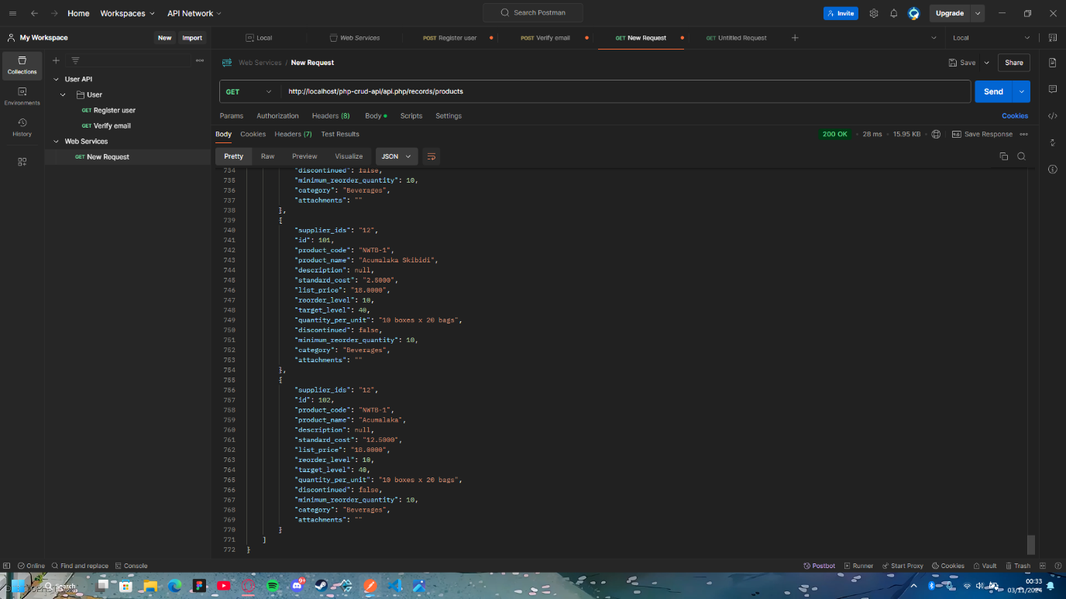

* Perintah PUT

{

"supplier_ids": "12",

"product_code": "NWTB-1",

"product_name": "Acumalaka Skibidi",

"description": null,

"standard_cost": "2.500",

"list_price": "18.0000",

"reorder_level": 10,

"target_level": 40,

"quantity_per_unit": "10 boxes x 20 bags",

"discontinued": false,

"minimum_reorder_quantity": 10,

"category": "Beverages",

"attachments": ""

}

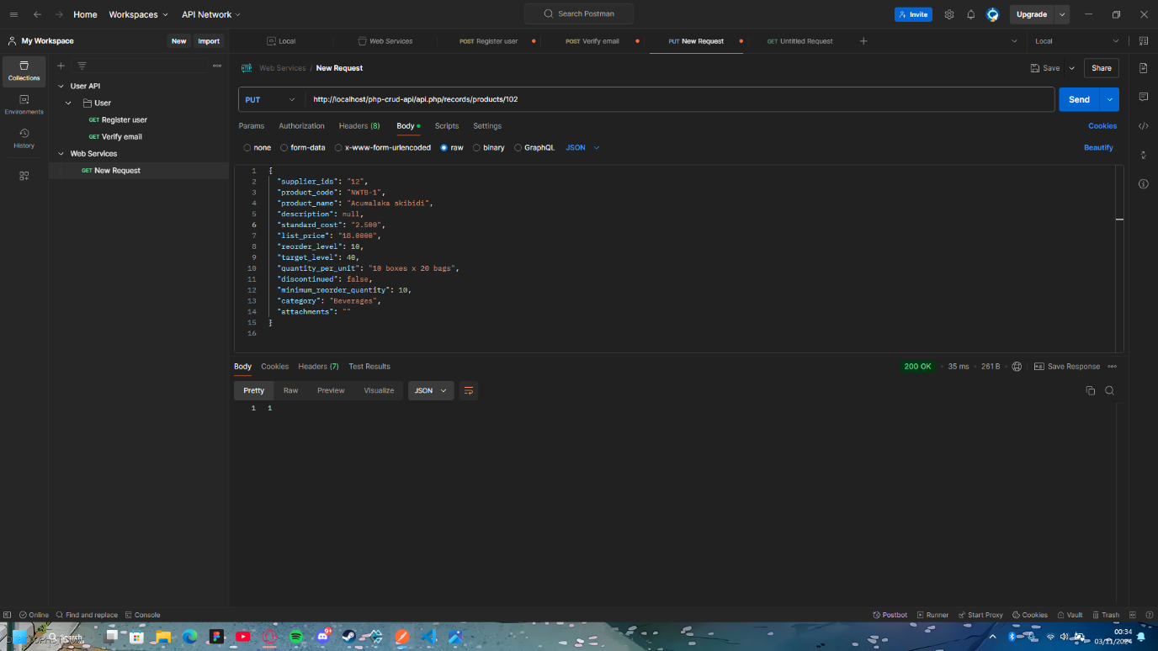

**Hasil Output :**

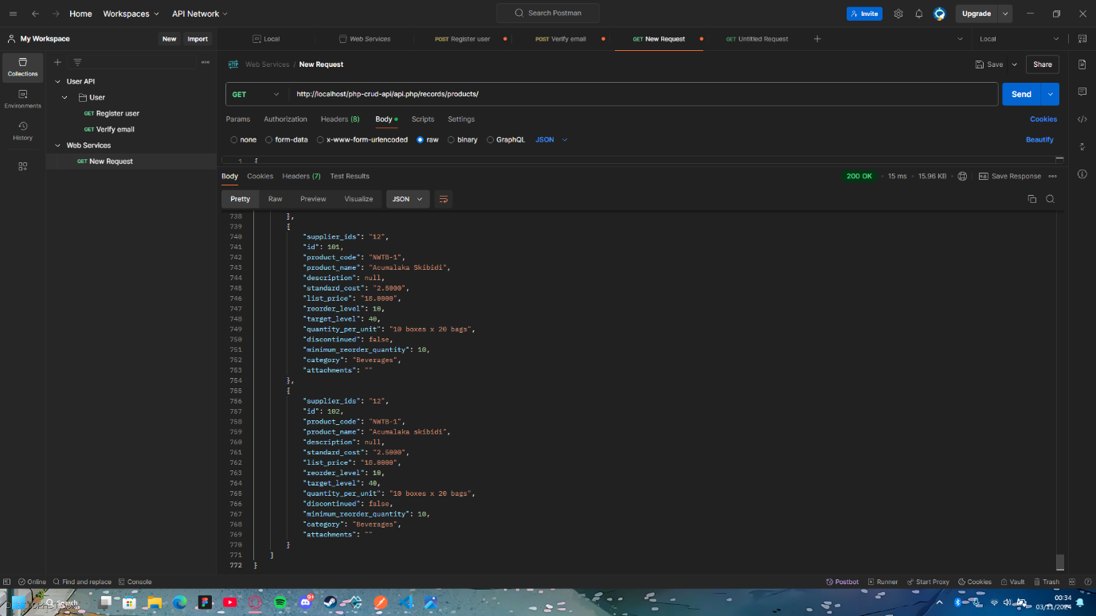

* Perintah DELETE

*http://localhost/php-crud-api/api.php/records/products/101*

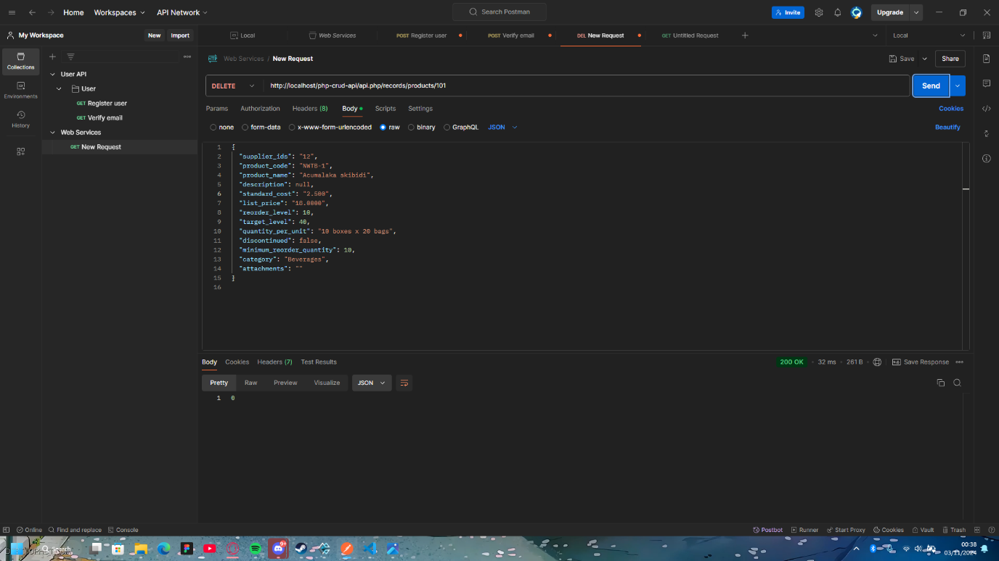

**Hasil Output :**